Register and Fundraise for DAWS at our | 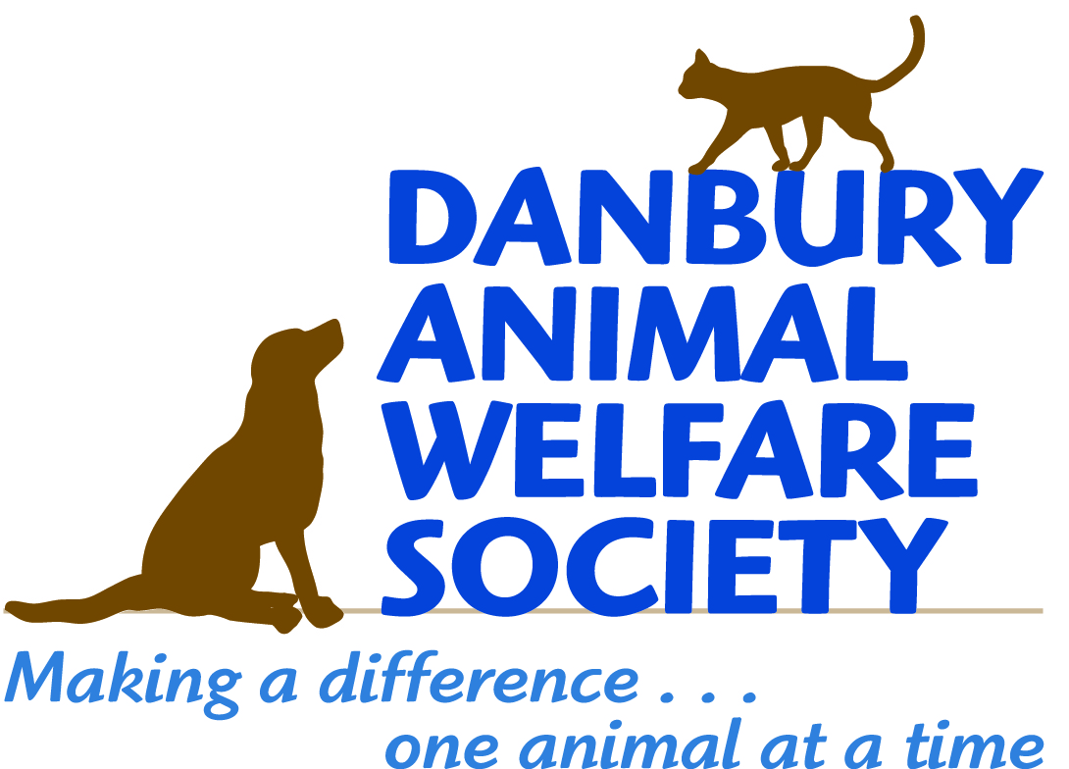
29th Annual Walk for Animals
September 16, 2018

Follow these simple steps to register for the Walk for Animals and set up a fundraising page to support our event. We need your support to continue making a difference in the lives of animals in need.

Follow these steps to register and set up your individual fundraising page:

- Visit http://www.firstgiving.com/DAWS/29th-Annual-Walk-for-Animals. Click the green button "Register" and select the number of people you would like to register
- If you already have a FirstGiving account, sign in with your user name and password
- If you don’t already have a FirstGiving account, enter your email address, name and contact information to create an account. When entering your information, FirstGiving will suggest a URL to be used as your personal donation page when you choose to fundraise for DAWS.
- Click “Create account”
- Answer a few registration questions and accept the Participation Waiver
- Click “Next”
- If you would like to be part of team, select it now or “Create a new team,” and follow instructions to name your team
- Click “Next”
- Create your personal online fundraising page (see example below)
- Choose a name for your fundraising page or use the one provided by FirstGiving
- Upload a photo you want to share (optional)
- Create a brief personal story about why you are walking and fundraising for DAWS
- Set a fundraising goal (we ask all participants to set a goal of $100 or more)
- Click “Next”
- Enter payment information
- Click “Submit”

What’s Next?
Share your page with friends, family, and co-workers, and ask them to support you by making a donation to DAWS. FirstGiving will provide you a personalized URL to send to your supporters to access your fundraising page. You can also enter donations made offline (see offline fundraising form below). You can customize your page by adding photos, videos and your own thank you message to your donors.

On September 16th, visit the Pre-Registration Desk.
Thank you for supporting DAWS!

Fundraising Sheet
DAWS 29th Annual Walk for Animals
September 16, 2018

Fundraiser Name: _______________________________________

Email address: __________________________________________
Please collect all money prior to the Walk on September 16, 2018. Cash or checks should be made payable to Danbury Animal Welfare Society. Turn in this form with donations on the day of the event.

Donor’s Name | Email Address | Phone Number | Pledge Amount | Paid  Cash Check
 |  | Total | $

Danbury Animal Welfare Society is a 501(c)3 charitable organization and your donation is tax deductible. We thank you for your support. For more information on the event or DAWS please visit our website at www.daws.org or email us at walk@daws.org.

Danbury Animal Welfare Society is a non-profit, volunteer-run organization dedicated to improving the lives of animals in our community and beyond.
Founded in 1974, we provide shelter and care to animals in need, offer adoption counseling to place our animals in loving, forever homes, promote responsible pet guardianship and the humane treatment of animals. We also work towards ending animal overpopulation through education, spay/neuter, and trap-neuter-return programs.

Example Fundraising Page Content:
Thank you for visiting my fundraising page! For the (ENTER) year, I invite my friends, family, and colleagues to help me raise funds to support Danbury Animal Welfare Society (DAWS).
For over 40 years DAWS has opened the door to hope for thousands of animals in need. As a no-kill animal shelter, DAWS provides shelter, food, medical care, and love to these animals until they can find forever homes. DAWS also educates our community about the importance of spaying and neutering by offering low-cost spay/neuter programs, and promotes the importance of adopting animals rather than buying them from pet stores and breeders.
DAWS has served the community in these ways thanks to kind and generous donors who help us raise over $700,000 each year to continue our life-saving work. Here are just a few ways your donation helps our animals:
- $25 feeds the dogs and cats in our shelter for one day
- $75 gives funds to buy one day's worth of supplies used in our on-site clinic
- $125 ensures we have heat, electricity, and water for one day

On behalf of the many animals currently in DAWS care, thank you for your support!
YOUR NAME
YOUR AFFILIATION WITH DAWS (such as adopter or volunteer) – OPTIONAL

Example Email Content:
Hello friends,
Many of you know how deeply I care about animals and the pets in my life. I am the proud adoptive parent of (ENTER YOUR ADOPTED PET) from Danbury Animal Welfare Society (DAWS).
I’ve also been a volunteer at DAWS for (ENTER HOW LONG AND YOUR VOLUNTEER ROLE). The kindness and generosity of donors and sponsors help DAWS make a difference in the lives of animals. I am participating in the Annual Walk for Animals to help the organization raise money to continue its life-saving work. I am asking for your support to sponsor me during this important event. Your donation, in any amount, will help the animals we care for.
To learn more about DAWS, see how your donation helps, and to make a donation, please visit my fundraising page. Your support is greatly appreciated!
THANK YOU!

