Register and Fundraise for DAWS at the | 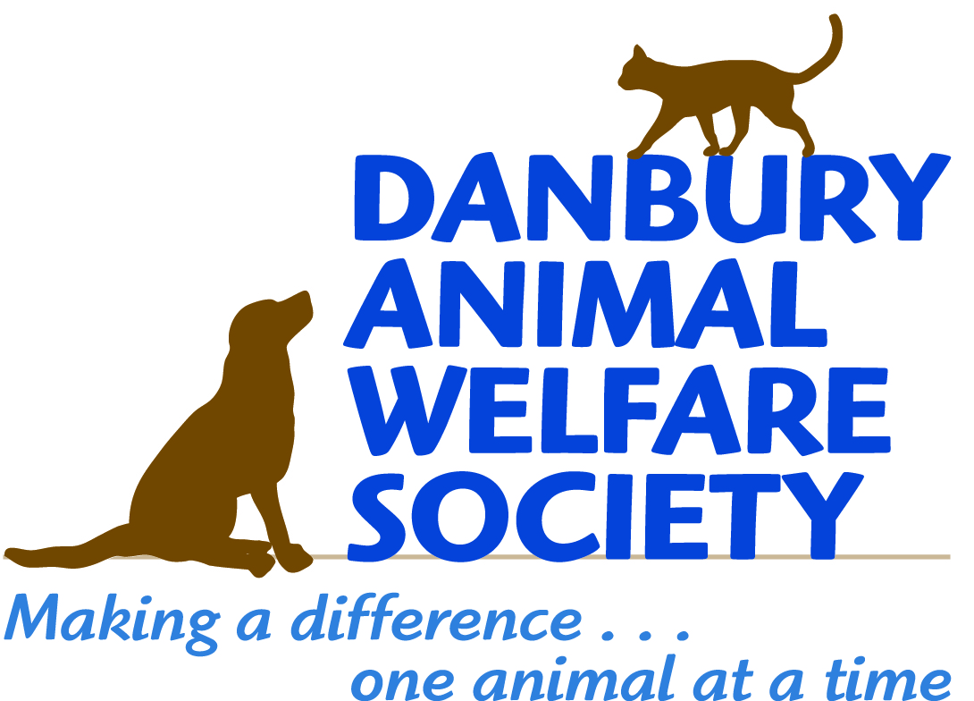
28th Annual Walk for Animals
June 11, 2017

Following these simple steps will help you register for the Walk for Animals and set up a fundraising page to support our event. We need your support to raise funds to help us continue to live our Mission.

Follow these steps to register and set up your individual fundraising page:

- Visit https://www.firstgiving.com/2344/28th-annual-walk-for-animals
- Click the green button "Register" and select the number of people you would like to register
- If you already have a FirstGiving account, sign In with your user name and password
- If you don’t already have a FirstGiving account, enter your email address, name and contact information to create an account. When entering your information, FirstGiving will suggest a URL to be used as your personal donation page when you choose to fundraise for DAWS.
- Click “Create account”
- Answer a few registration questions and accept the Participation Waiver
- Click “Next”
- If you would like to be part of team, select it now or “Create a new team,” and follow instructions to name your team
- Click “Next”
- Create your personalized online fundraising page (see example below)
- Choose a name for your fundraising page or use the one provided by FirstGiving
- Upload a photo you want to share (optional)
- Create a personal story to share about why you have decided to walk and fundraise for DAWS
- Set a fundraising goal* (*We ask that each participant raise at least $100 for DAWS)
- Click “Next”
- Enter payment information
- Click “Submit”

What’s Next?
Share your page with friends, family, and co-workers, and ask them to support you by making a donation to DAWS. FirstGiving will provide you a personalized URL to send to your supporters to access your fundraising page. You can also enter donations made offline (see offline fundraising form below). You can continue to customize your page by adding photos and videos and by creating your own thank you message to your donors.

On June 11th, visit the Pre-Registration Desk.
Thank you for supporting DAWS!

Fundraising Sheet
DAWS 28th Annual Walk for Animals
June 11, 2017

Fundraiser Name: _______________________________________

Email address: __________________________________________
Please collect all money prior to the Walk on June 11, 2017. Cash or checks should be made payable to Danbury Animal Welfare Society. Turn in this form with donations on the day of the event.

Donor’s Name | Email Address | Phone Number | Pledge Amount | Paid  Cash Check
 |  | Total | $

Danbury Animal Welfare Society is a 501(c)3 charitable organization and your donation is tax deductible. We thank you for your support. For more information on the event or DAWS please visit our website at www.daws.org or email us at walk@daws.org.

Danbury Animal Welfare Society is a non-profit, volunteer-run organization dedicated to improving the lives of animals in our community and beyond.
Founded in 1974, we provide shelter and care to animals in need, offer adoption counseling to place our animals in loving, forever homes, promote responsible pet guardianship and the humane treatment of animals. We also work towards ending animal overpopulation through education, spay/neuter, and trap-neuter-return programs.

Example Page Content:

Tania Buchmelter's Walk for Animals Page
Thank you for visiting my fundraising page! For the seventh year in a row, I am seeking the support of my friends, family, and colleagues to help me raise funds to support Danbury Animal Welfare Society (DAWS).
For over 40 years DAWS has been opening the door to hope for thousands of animals in need. As a no-kill animal shelter, DAWS provides shelter, food, medical care, and love to nearly 1000 animals each year until they can find forever homes. DAWS also works tirelessly toward the goal of ending animal overpopulation by educating the community about the importance of spaying/neutering, offering low-cost spay/neuter programs to the community, as well as promoting the importance of adopting animals versus buying them from pet stores and breeders.
DAWS has been serving the community since 1974 thanks to the kindness and generosity of donors and sponsors. This year DAWS needs to raise over $700,000 to continue its life-saving work. Your donation goes a long way to helping ensure that happens. Here's how:
- $25 feeds the dogs and cats in our shelter for one day
- $75 gives funds to buy one day's worth of supplies used in our on-site clinic
- $125 ensures we have heat, electricity, and water for one day

On behalf of the many animals currently in DAWS care, I thank you for your support!
Tania
Chairperson, Marketing Committee
Dog Volunteer
Community Outreach Ambassador

Example Email Content:

Hello colleagues and friends,
Many of you know that I am passionate about animals and animal welfare. Pets have been part of my life since childhood, and I can’t imagine a life without animals. Today my husband and I are the proud parents of two cats rescued from Danbury Animal Welfare Society (DAWS).
I became a volunteer at DAWS in 2011, five long years after saying goodbye to our beloved dog, Alexandra. Since then, I have been faithfully walking dogs every Tuesday and Saturday and supporting the organization in as many ways possible.
DAWS relies on the kindness and generosity of donors and sponsors to raise funds to help make a difference in the lives of animals. I am participating in the 28th Annual Walk for Animals to help the organization raise money to continue its life-saving work. I am asking for your support to sponsor me during this important event. Your support will help DAWS continue its lifesaving work.
No donation is too small, and any support you can provide will help.
To learn more about the great work DAWS does, see how your donation helps, and to make a donation, please visit my fundraising page.
Your support is greatly appreciated!
THANK YOU!

